Problem I

In this problem, we load calculate some statistics for each hashtag such as average

number of tweets per hour, average number of followers of users posting the tweets,

and average number of retweets.

Every hashtag information is loaded from the corresponding hashtag file into python by reading JSON objects. Each line in the file representing a tweet was parsed to extract

information regarding the corresponding hashtag.

We calculate the metrics using following formulas:

$$Average number of tweets per hour=\frac{Total number of tweets}{Total number of hours}$$

$$Average number of retweets per hour=\frac{Total number of retweets}{Total number of tweets}$$

$$Average number of followers per user =\frac{Total number of followers}{Total number of unique users}$$

Metrics for each tag is as follows:

|  |  |  |  |
| --- | --- | --- | --- |
| **Hashtag** | **Average number of tweets per hour** | **Average number of retweets per hour** | **Average number of followers per user** |
| **#gohawks** | 193.5555 | 2.01461 | 1544.9697 |
| **#gopatriots** | 38.4070 | 1.4000 | 1298.8242 |
| **#nfl** | 279.4217 | 1.5385 | 4289.7466 |
| **#patriots** | 499.1977 | 1.7828 | 1650.3219 |
| **#sb49** | 1420.8780 | 2.5111 | 2235.1636 |
| **#superbowl** | 1400.5887 | 2.3882 | 3591.6044 |

Bar graph for each hashtag is as follows:



**Figure 1 :** Figure illustrating Number of tweets per hour for gohawks hashtag over the duration of time



**Figure 2:** Figure illustrating Number of tweets per hour for gopatriots hashtag over the duration of time



**Figure 3:** Figure illustrating Number of tweets per hour for nfl hashtag over the duration of time



**Figure 4 :** Figure illustrating number of tweets per hour for patriots hashtag over the duration of time



**Figure 5 :** Figure illustrating number of tweets per hour for sb49 hashtag over the duration of time



Figure 6 : Figure illustrating number of tweets per hour for superbowl hashtag over the duration of time

**Analysis of Statistics:**

1. Most retweeted Hashtag on an average: **#superbowl and #sb49**
2. Most tweeted Hashtag on an average: **#superbowl and #sb49**
3. Most followers to users tweeting hashtag: **#nfl and** **#superbowl**

This analysis can also be visualized from Figure 6 (superbowl) , Figure 5 (sb49) and Figure 3(nfl). Figure 5 and Figure 6 show steep rise which is indicative of high activity for that hashtag.

Problem II

In this problem, we make predictions for tweets in the next hour based on the features collected from previous hour tweet. The features on which this linear regression model is build are as follows:

1. Number of tweets
2. Total number of retweets
3. Sum of the number of followers of the users posting the hashtag
4. Maximum number of followers of the users posting the hashtag
5. Time of the day (indicating an hour out of 24 hours)

An hour window approach same as problem I is employed to calculate the features information for any given hour to make predictions for next hour.

We obtained the summarized results after fitting the linear regression model for each hashtag. Summarized reports for each hashtag are as follows:

1. #gohawks

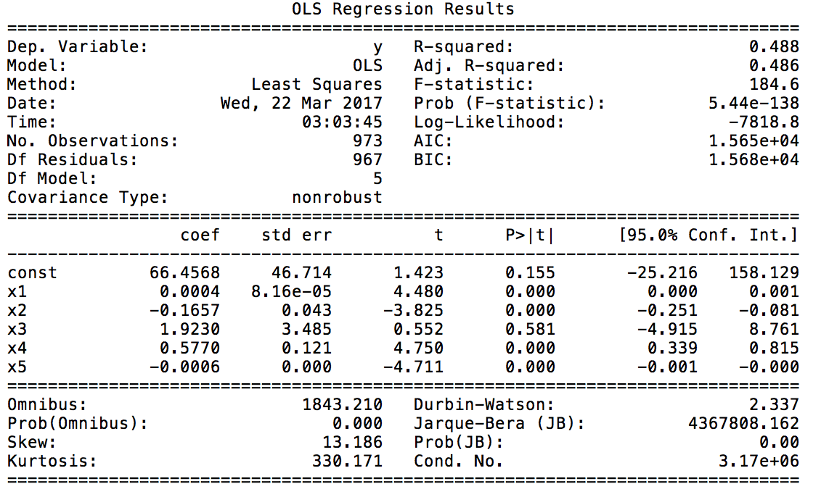

Report 1 : OLS Regression Results for **gohawks** hashtag**. R-squared accuracy** can be observed as **0.488** indicating not a good fir to the model for this hashtag.

1. #superbowl

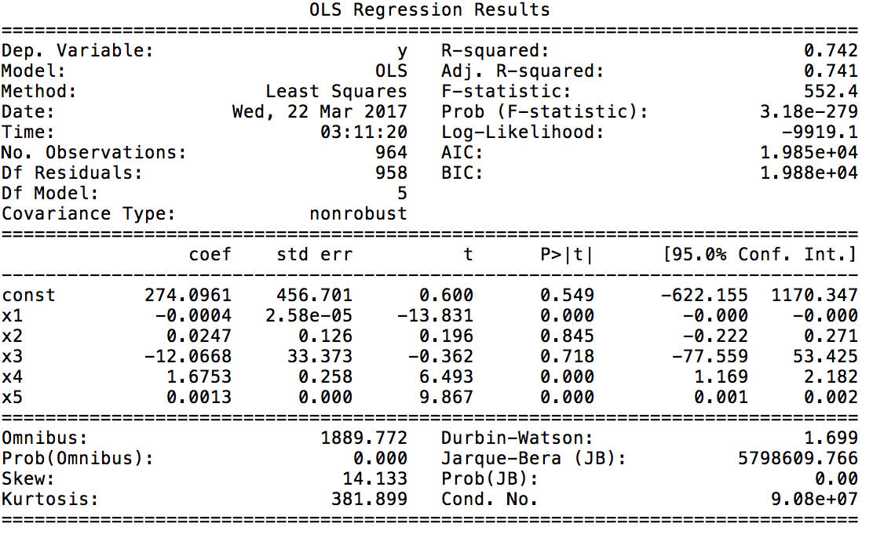

Report 2 : OLS Regression Results for **superbowl** hashtag. **R-squared accuracy** can be observed as **0.742** indicating a good fit to the model for this hashtag.

1. #gopatriots

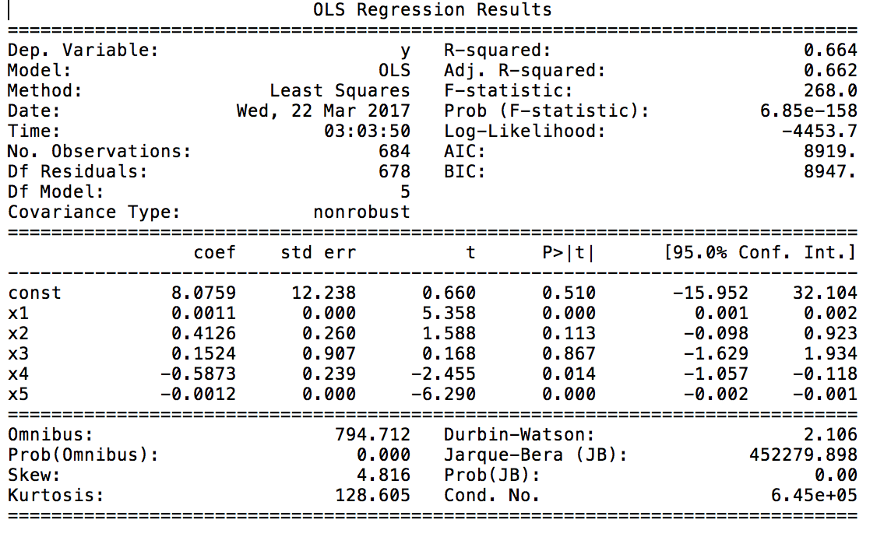

Report 3 : OLS Regression Results for **gopatriots** hashtag. **R-squared accuracy** can be observed as **0.664** indicating a decent fit to the model for this hashtag.

1. #sb49

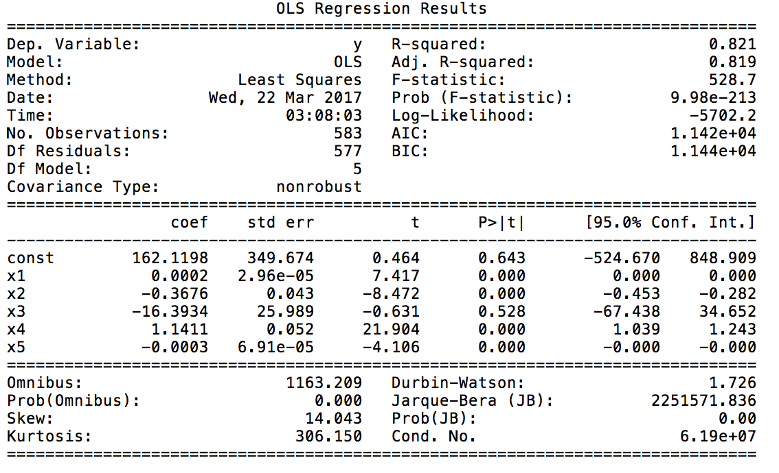

Report 4 : OLS Regression Results for **sb49** hashtag. **R-squared accuracy** can be observed as **0.821** indicating a very good fit to the model for this hashtag.

1. #nfl

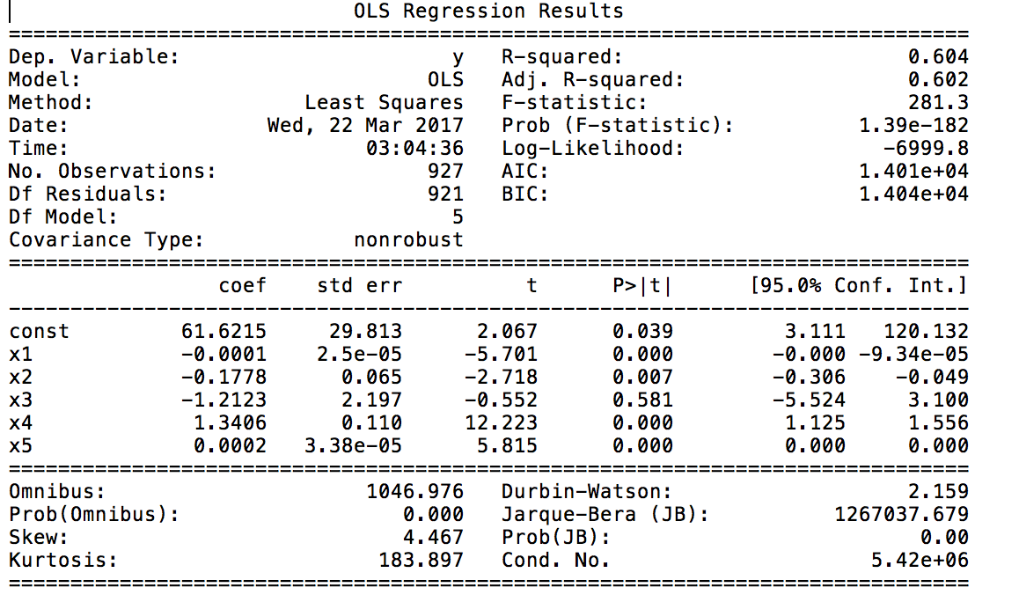

Report 5 : OLS Regression Results for **nfl** hashtag**. R-squared accuracy** can be observed as **0.604** indicating a decent fit to the model for this hashtag.

1. #patriots

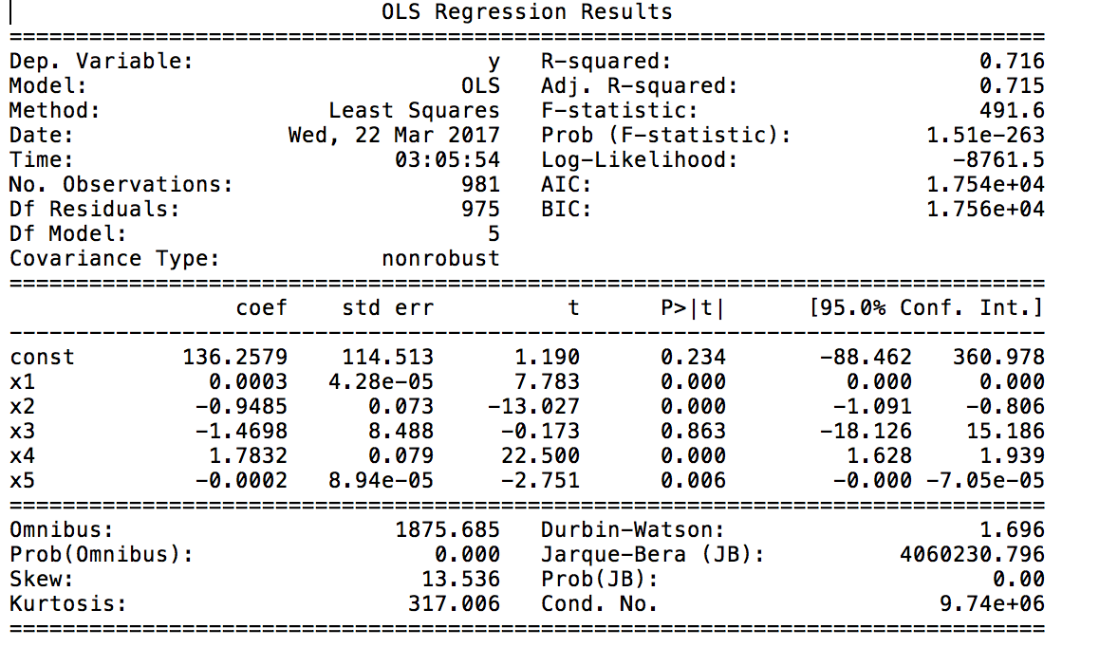

Report 6 : OLS Regression Results for **patriots** hashtag. **R-squared** accuracy can be observed as **0.716** indicating a good fit to the model for this hashtag.

The results obtained for each hashtag shown above are summarized below:

|  |  |
| --- | --- |
| Hashtag | Accuracy value |
| #gohawks | 48.8329 |
| #superbowl | 74.2456 |
| #gopatriots | 66.4003 |
| #sb49 | 82.0842 |
| #nfl | 60.4277 |
| #patriots | 71.6007 |

Table 1 : Model accuracy for each hashtag

|  |  |  |  |  |  |
| --- | --- | --- | --- | --- | --- |
| Hashtag | Maximum followers count | Retweet count | Time | Tweet Count | Follower Count |
| #gohawks | 8.345 * 10-6 | 1.392 * 10-4 | 5.811 * 10-1 | 2.347 * 10-6 | 2.826 * 10-6 |
| #superbowl | 8.458 * 10-40 | 8.445 * 10-1 | 7.177 * 10-1 | 1.351 * 10-10 | 6.144 * 10-22 |
| #gopatriots | 1.155 * 10-7 | 1.127 * 10-1 | 8.666 * 10-1 | 1.433 *10-2 | 5.690 * 10-10 |
| #sb49 | 4.308 * 10-13 | 2.014 * 10-16 | 5.284 * 10-1 | 7.413 *10-78 | 4.600 * 10-5 |
| #nfl | 1.606 * 10-8 | 6.691 * 10-3 | 5.812 * 10-1 | 6.032 * 10-32 | 8.350 * 10-9 |
| #patriots | 1.806 * 10-14 | 7.023 * 10-36 | 8.625 * 10-1 | 1.257 * 10-90 | 6.057 * 10-3 |

Table 2 : p-values for model parameters

|  |  |  |  |  |  |
| --- | --- | --- | --- | --- | --- |
| Hashtag | Maximum followers count | Retweet count | Time | Tweet Count | Follower Count |
| #gohawks | 4.478 | -3.824 | 0.551 | 4.747 | -4.710 |
| #superbowl | -13.830 | 0.196 | -0.361 | 6.492 | 9.867 |
| #gopatriots | 5.357 | 1.587 | 0.167 | -2.455 | -6.290 |
| #sb49 | 7.416 | -8.471 | -0.630 | 21.904 | -4.106 |
| #nfl | -5.700 | -2.717 | -0.551 | 12.222 | 5.815 |
| #patriots | 7.782 | -13.026 | -0.173 | 22.499 | -2.750 |

Table 3 : t-values for model parameters

**Analysis of results:**

1. Accuracy:
   1. We have used R-squared accuracy as a parameter to analyze the fit to the data. Higher R-squared accuracy indicates a better fit of model to the data.
   2. It can be observed that model fits the data better for #sb49 and #superbowl with accuracies as 82% and 74.2%
2. P-value and t-value:
   1. T-value is used to statistically determine significance of a variable in the model. It is important to pick the significant features while designing the regression model. The larger the absolute value of t, less likely the value of parameter could be zero. Thus we would want to select features with higher t-value.
   2. Lesser the p-value, higher the probability of being important feature for the model. Thus we want to select features with lower p-value.
   3. Based on analysis of p-value and t-value, significant features for each hashtag are as follows:
      1. #gohawks : Tweet count, Maximum followers count
      2. #superbowl : Tweet count, Follower count
      3. #gopatriots : Maximum followers count, Retweet count
      4. #sb49 : Tweet count, Maximum followers count
      5. #nfl : Tweet count, Follower count
      6. #patriots : Tweet count, Maximum followers count
   4. It can be observed that Tweet count and Maximum followers count are important features across all hashtags

Problem III

'''

Now all the hashtags were trained with all the fourteen parameters that we had selected.

X1: sum_ranking_score ( Ranking score)

X2: retweets_count

X3: tweets_count

X4: max_listed_count

X5: total_verified_users

X6: user_count

X7: avg_favorite_count

X8: url_count

X9: max_favorite_count

X10: followers_count

X11: avg_user_mention_count

X12: time

X13: avg_listed_count

X14: max_followers

From the previous model training we identified the best features and trained new models.

Too many parameters can lead to over fitting. So we selected the best features for each.

#gohawks : X1, X6, X11, X13, X14

#gopatriots : X1, X8, X11, X13, X14

#nfl : X3, X11, X13, X14

#patriots: X1, X5, X6, X10, X11

#sb49 : X1, X2, X6, X11, X13

#superbowl : X2, X6, X9, X13, X14

'''

Number of tweets

Total number of retweets

Sum of number of followers

Max number of followers

Time of the data

Ranking score

Impression count

Favorite count

Number of users per hour

Number of long tweets per hour : counted tweet length > 100

tweets_count (Number of tweets)

retweets_count (Total number of retweets)

sum_ranking_score (Ranking score)

Impression count

followers_count (Sum of number of followers)

max_followers(Max number of followers)

avg_favorite_count

sum_ranking_score(Ranking score)

time ( Time of the data)

avg_favorite_count (Total Favorite count) – not avg

avg_user_mention_count ( Total time user was mentioned)

Number of long tweets per hour : counted tweet length > 100

X4: max_listed_count

X5: total_verified_users

X6: user_count

X8: url_count

X9: max_favorite_count

X13: avg_listed_count

Number of users per hour